
Name Click or tap here to enter text.  Form completed by Click or tap here to enter text. | 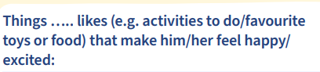  Click or tap here to enter text.
  Click or tap here to enter text. |   Click or tap here to enter text.
  Click or tap here to enter text. | 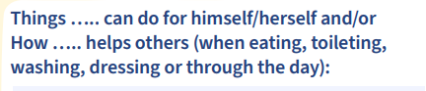  Click or tap here to enter text.
  Click or tap here to enter text. | Any allergies/SEN/medical conditions we should know about…..  Click or tap here to enter text.
To be completed with school staff (For children having a home visit).
Special friends/family | Ways we can help…… to settle
Anything else we should know

